TECHNICAL SHEET

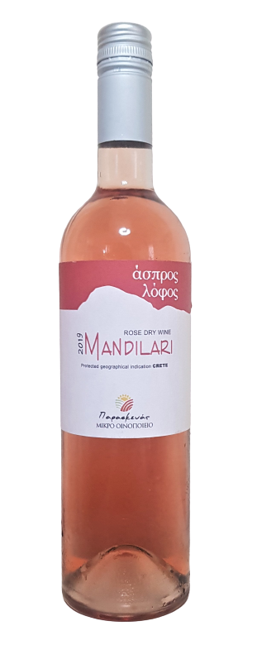
LABEL | ASPROS LOFOS
VARIETIES | MANDILARI
STYLE | DRY ROSE P.G.I CRETE
TERROIR | VINEYARD REGION  PLATI PERAMA KROUSONA  (8 ACRES OF VINES, ORIENTED EAST, CLAY SOIL AND HIGH LEVELS OF NATURAL DRAINAGE
VINIFICATION | EXTRACTION PROCESS AFTER THE FIRST 2 HOURS.  MATURATION IN INOX TANKS
ABV% | 12%

