TECHNICAL SHEET

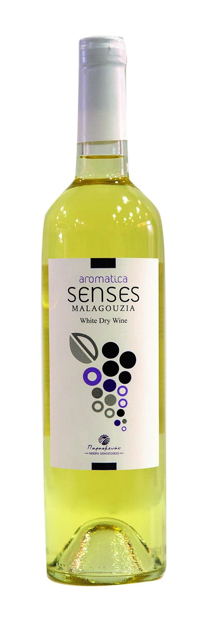
LABEL | SENSES
VARIETIES | 95% MALAGOUZIA 5% MUSCAT OF SPINA
STYLE | DRY WHITE
TERROIR | MALAGOUSIA VINES ARE LOCATED AT SARHO MALEVIZI IN VOTHONIA.240m. OF ALTITUDE, IN A VALLEY SURROUNDED BY SMALL HILLS  WHILE, MUSCAT OF SPINA, IS BEING PLANTED IN KAZOLA PIRGOU OF HERAKLION REGION. IN 340m. ALTITUDE ,SLOPY, LIMESTONE SOIL, SEMIMOUNTANEOUS WITH GREAT NATURAL DRAINAGE. ORIENTED SOUTH AND WEST
VINIFICATION | BATTONAGE FOR 1 WEEK IN OUR INOX TANKS (2.000 lt EACH).  MATURATION IN INOX TANKS
ABV% | 13%

